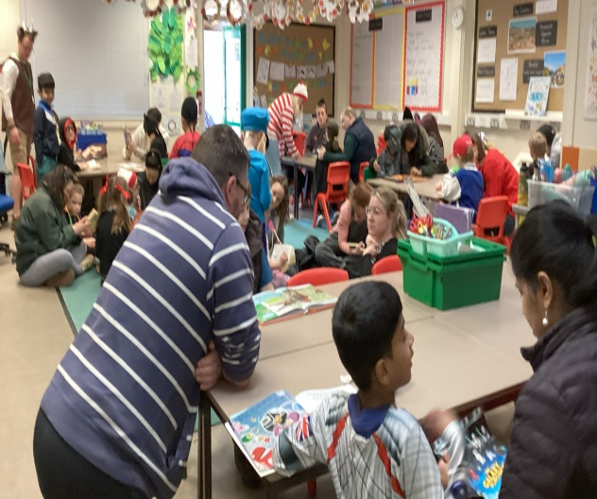
World Book Day: It was wonderful to see so many children - and parents - immersed in books at school yesterday morning. The children’s excitement was contagious, from their creative costumes to the books they shared throughout the day, showing just how much they love reading. Encouraging a love of reading is a the heart of what we do in school. In today’s busy world, there is nothing more magical than sharing a book with a family member. Please continue to support your children by making every day a celebration of reading – just like World Book Day!
From Mr Chappell: It’s that time of year – where I begin my newsletter with the same message to our whole school community. From Term 4 onwards the weeks always seems to fly by, and it is a time when we start to see the children continue to grow and mature, both emotionally and socially. Technically, we are now just past the halfway point of the year, for example Year 5.5. As the children know from their Maths work, when you reach 0.5 you round up to the nearest whole number, so in reality Year 5.5 is the beginning of Year 6! With that in mind, this is the point in the year when we begin to raise expectations and standards once again and we move into the final few terms. Seeing the progress that all of the children have made over the first three terms has been fantastic, and it will be great to see what they can achieve during the remainder of the year. Have a great weekend!

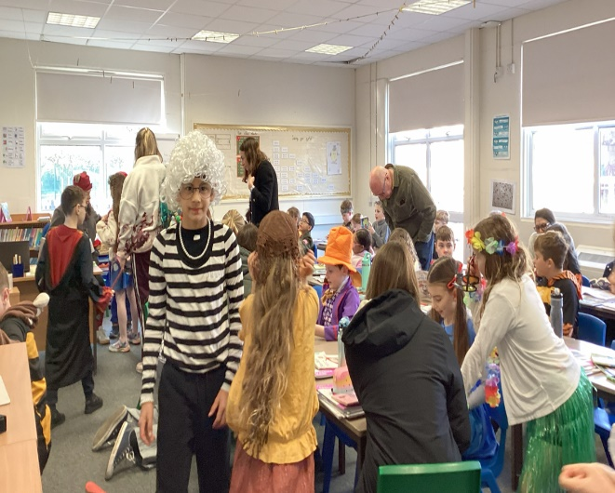
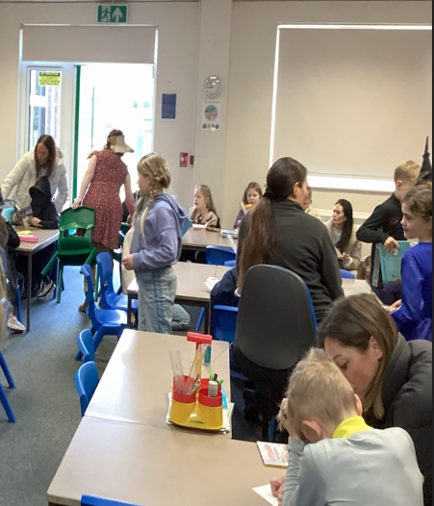
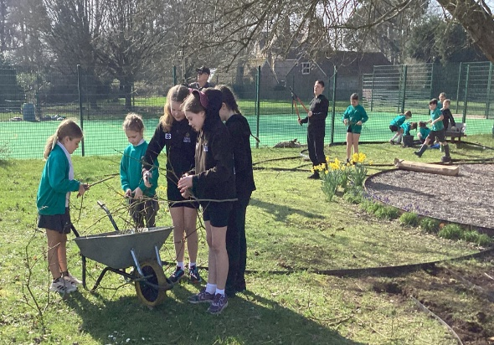
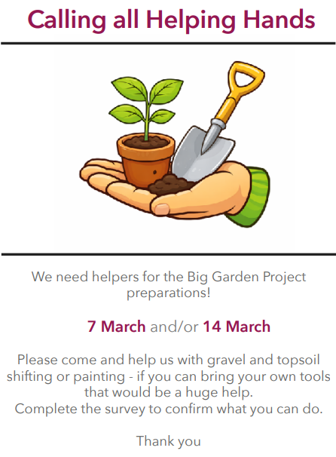
FOSH: Over the past few days, you may have noticed some changes being made to the garden area. A huge thank you to everyone who has volunteered to support FOSH as we begin making some exciting improvements to the space. This work has been led by Emma Gordon, the new chair of FOSH, who has sucessfully secured several grants to make these developments possible.

Thank you to the few who have signed up to help with the garden on Saturdays 7 & 14 March. There’s plenty to do and many hands make light work so if you can join us, please complete this survey to confirm:
https://www.surveymonkey.com/r/ZXRKKJ2
We will be starting from 9am until potentially 4pm for those that can but any help would be much appreciated.
This year sees school celebrate its 60th anniversary and FOSH are bringing a real celebration to school before the academic year is out! We have lots of exciting ideas and events we’d love to provide, as well as new and exciting fundraising for a much-needed upgrade to the ICT suite. Trust us - you and the children will want to see this colourful event happen…! We need lots of support to run this 😉 so save the date for our next online meeting on 22 March at 7.30pm and look out for the link in class groups. We need to know who can help to decide what we can do, so see you there! Thank you.

Curriculum Showcase: A reminder that on Wednesday 18th March we will be opening the doors to all classrooms (not just your own child’s) so that you can see the fantastic work taking place right across the school as part of our annual Curriculum Showcase. Each class will have some wonderful examples of work on display in their classrom. Please also take the time to explore the corridors, where each class will have their final outcomes displayed on their dedicated showcase boards. On the day, you are very welcome to move around the school and visit every classroom and corridor. It is always particularly inspiring for parents of children in Year R and Year 1 to see the kind of work children are producing by the time they reach Year 6. During the event, there will also be a taster session in the hall, hosted by our caterers Dolce, where you can try some of the delicious food that Heather and Clare (our brilliant cooks) serve up every day.

New clubs this week:
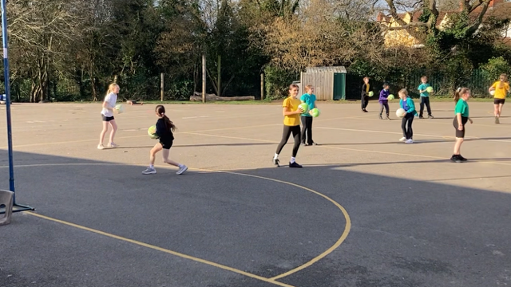
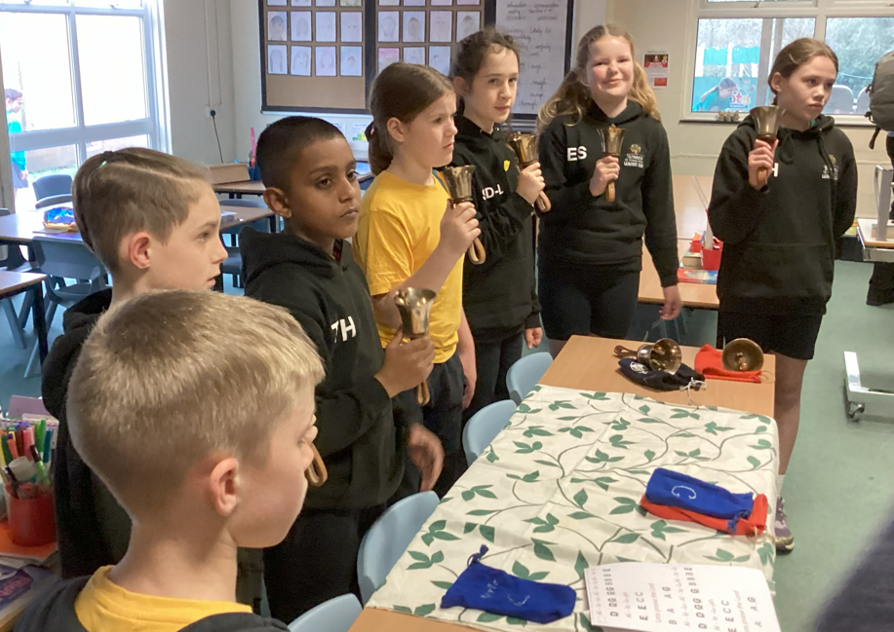

Bell Ringing Club – ready for Mothering Sunday in Church. Netball club run by two parents Alice K and Claire GS
Once again, our enrichment opportunities continue to be extremely popular, with large numbers of children taking part and thoroughly enjoying what’s on offer. A huge thank you to everyone who gives up their time to run and support these clubs.

The advert for casual school Meals Supervisory Assistants (SMSA) is still live (see link below), and we warmly welcome applications from anyone in the community. Paper application forms are also available from the school office.
https://www.eteach.com/job/casual-smsa-school-meals-supervisory-assistant-1530900

Key Dates:
Parents / Carers Meetings: Year 1 – Year 6 | Term 5: 28th and 30th April
Wednesday 18th March | Curriculum Showcase – all classrooms open to all parent / carers.
Thursday 2nd April | FOSH Non-uniform Day
Monday 15th June Sports Day | KS1 9:15 am KS2 10:45 am (Reserve Day Tuesday 16th June.
Tuesday 14th July | Reports to Parent / Carers
Inset Days:
Monday 23rd March
20th July 21st July
Key Statutory Dates – all pupils to undertake.
Monday 11th May – Thursday 14th May | Year 6 SATs assessments week
Monday 8th June – Friday 12th June | Year 1 Phonics Tests and Year 2 Phonics re-tests
Monday 1st June – Friday 12th June | Year 4 Multiplication Tables Check

Well done to those children who were awarded a certificate last week and today:
Holly Class: Ivy & Dexter Arthur & Milo
Beech Class: Mylah & Charlie Navy & Rocky-Roy
Oak Class: Annabelle & Amber-Rae Eli & Jenson
Ash Class: Luna & Molly Elle & Lucas
Sycamore Class: Ozzie & Ciara Fred & Bavisha
Elm Class: Ruben & Isla George & Chloe
Mr Chappell’s award: Bea (Elm Class) & Logan (Elm Class)

