Reading | Big Maths Learn Its
Read and discuss books together after school, before school, in the car, in fact almost anytime and anywhere. Enjoy 4-5 pages at a time, at least 5 times a week. Note this in your reading record with a date and an adult’s signature. Bring in books and reading records on Fridays. | 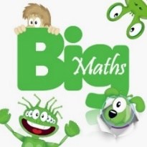  A few mathematical facts for you to learn off by heart: very rapid recall! These progress systematically and need quick reactions and no fingers! Learn Its challenges will take place each Friday and three facts will be highlighted to practice at home for the following week.
Spellings | Times Tables Rock Stars
Each week we will be focusing on a spelling pattern or particular group of words. Practise the spellings at home – suggestions of ways to do this are provided alongside this sheet. | Log in to Times Table Rock Stars and practise the times table and division facts for 20 minutes each week - that’s less than 3 minutes per day! Challenge yourself to beat your personal best!
Curriculum Home Learning
Our global theme this term is Peace and Conflict. In school this term, we will be learning a lot about conflict, focusing on World War Two.
At home, we would like you to spend some time thinking about peace and create something that you can bring in and share with the class.
Think about:
- What does peace mean to me?
- When and where do I feel most peaceful?
- What makes me feel peaceful?
- What would make our world a more peaceful place?
You can choose to present your ideas about peace however you like: a poem, a poster, a Powerpoint, a video, some artwork, a model, etc.
Each class member will bring in something to share at some point before half term break.
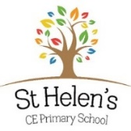
Year 5 Home Learning Term 1 2022

