Year 5 Spelling
In Year 5 and 6, there are some key words to learn how to read and spell, which are called the statutory words. We will also be learning how to spell words with specific spelling patterns.
Term 1
Our spelling learning in Term 1 will include:
- Dictionary skills
- Spelling strategies
- The ‘ough’ letter string e.g. though, through, enough, thought, although, brought, dough, cough
- Words with silent letters e.g. doubt, island, lamb, knight, debt, whistle, numb, autumn
- Words ending in ‘able’ and ‘ible’ e.g. horrible, terrible, possible, adorable, valuable, enjoyable
- Homophones e.g. aloud/allowed, affect/effect, herd/heard, past/passed, isle/aisle

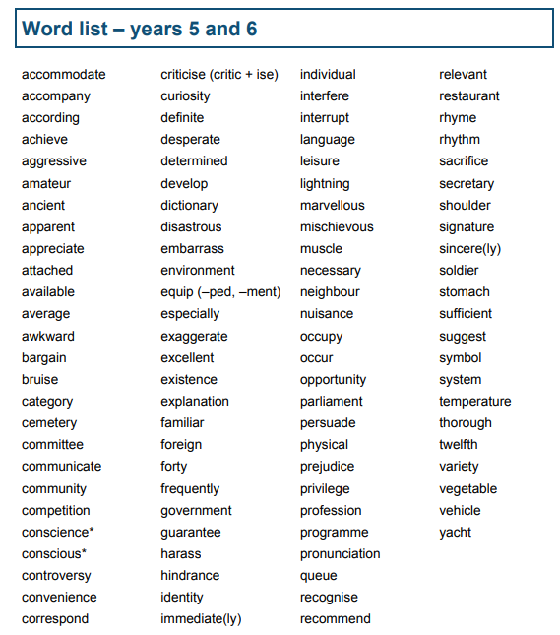
Helping Your Child Learn to Spell
Segment it!
Speak like a robot to say the separate sounds in a word. For example, to spell the word clear, say each sound in turn…/c/, /l/, /ear/. Write down the representation of each of these sounds.
Spelling Rules!
In school, your child will investigate certain spelling principles. It is important that your child understands the principle and can apply it to any word. To help them, they may be asked to consolidate their learning at home.
Approaches to support learning spellings visually:
Sometimes it is not possible to spell a word by segmenting it. Instead, your child will need to learn it by sight using some of the following strategies to help:
What is the difficult bit?
Talk with your child about the tricky bit of the word where the letters do not correspond to the sounds the children know (e.g. in different the difficult bit is the e in the middle because you can’t hear it.)
Which looks right?
Write a word 3 times, once spelled correctly and twice with an incorrect spelling. For example: becus, because, becuz. Ask you child to point out the one that looks right.
Sparkler Writing
Ask your child to close their eyes and imagine they are writing a word with a sparkler as you spell the word aloud.
Speed - write
Give your child 30 seconds to write a word down as many times as they can.
Words in words
Talk with your child about words that they can see within a word. For example, “Can you see the in they?”
Build it up
Write a word letter by letter.
Display:
On the wall next to where you eat, in the bathroom, up the stairs are all good places to display words.
Decorate/illustrate a word
Write a word for your child in ‘bubble’ writing. Use colouring pens/pencils, glitter etc.
Talk to your child about the word and its spelling.
Say it as it sounds
The funny pronunciation can help us remember how to spell a word e.g. “Wed-nes-day” rather than Wednesday.
Mnemonics
There are a few sight words where a mnemonic may help: said: Sally-Anne Is Delightful
could: C Oh U Lovely Duck! because: Big Elephants Can Always Understand Small Elephants
Look, Cover, Write, Check
Ask your child to look at the word. Then, cover it so they can not see it. Your child should then write it down. Finally, uncover the word and compare your child’s spelling with the correct spelling, talking about any differences.

w
wi
wit
with

which

was
was

