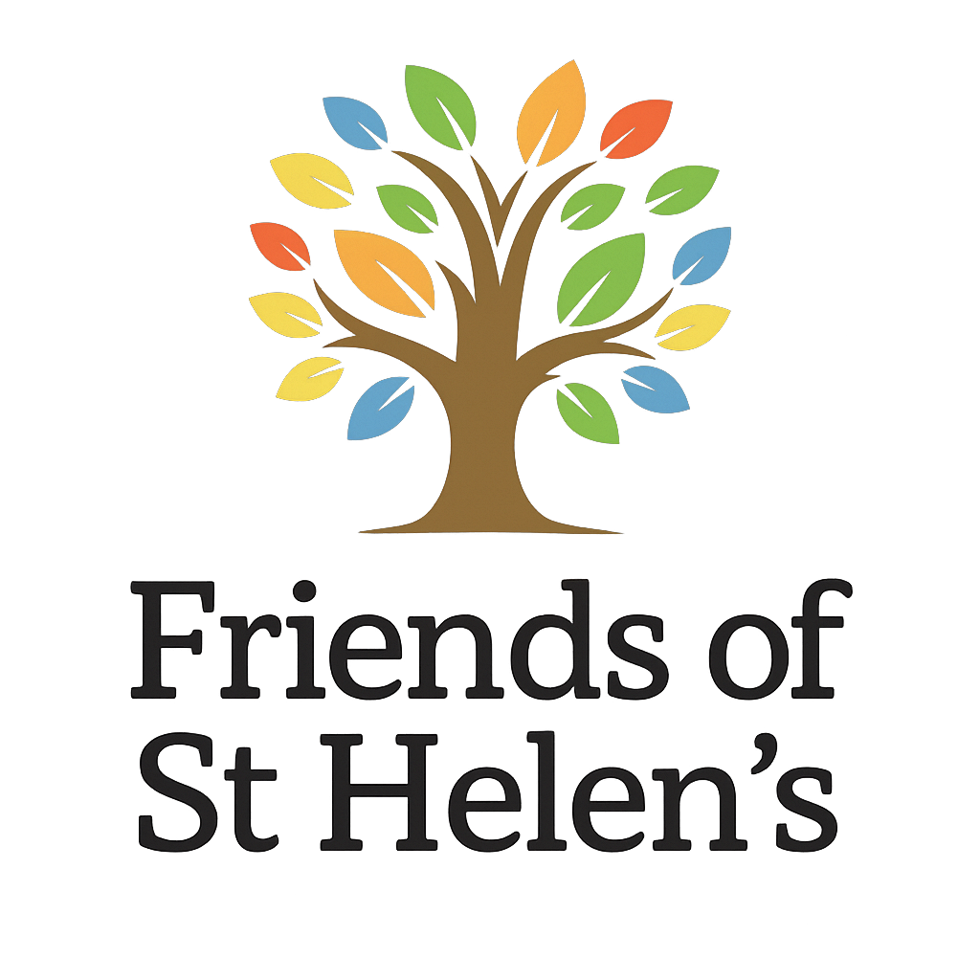
Dear Parents & Carers,
As part of St Helen’s School 60th Birthday celebrations and our fundraising events for this year, we are delighted to share a very special project with you.
The children have been asked to design a souvenir tea towel to help commemorate this milestone year. They have thoroughly enjoyed creating drawings of themselves and their teaching staff to feature on the tea towel and it looks fantastic!
If you would like to place an order, tea towels are priced at £6.00 each and can be purchased via the St Helen’s FOSH Shop Zeffy page:
https://www..zeffy.com/en-GB/organizations/st-helens-pta
ST HELENS PTA's Shop
We are also pleased to offer an early bird deal — purchase two tea towels for £10 by using the discount code DISCOUNT2FOR10 at checkout. This code will end on Sunday 24th May.
Please ensure all orders are placed by Sunday 31st May, so that we can ensure you get your orders in the Summer Term.
We hope you love these keepsakes as much as we do, and thank you, as always, for your continued support.
If you have any questions, please email foshalveston@gmail.com
Happy 60th Birthday St Helen’s School!
Friends of St Helen’s School
(FOSH)

